Spicy Parsnip and Apple Soup

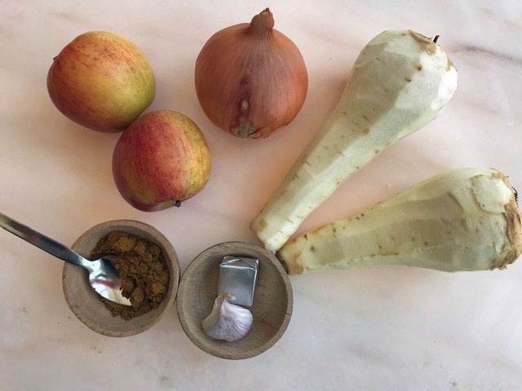

You will need:
2 Large Parsnips
1 large Onion
2 Apples
1 tablespoon of oil
1 clove of garlic
2 teaspoons of curry powder
1 stock cube

- Peel and chop up the parsnip into small pieces and peel and chop up the apple.
- Chop the onion into small pieces and start frying it slowly in a pan
- After about 5-6 minutes when the onion is transparent add the garlic and fry for a minute.
- Stir in the curry powder and then the parsnips and apples and fry gently for a minute.
- Add the stock to the pan and enough water to cover the parsnips and apples.
- Simmer for about 20-25 minutes until the parsnips are soft.
- Use a hand liquidiser to make a smooth soup. If the soup is too thick then add more water and re heat it.
- I put a teaspoon of cream and some coriander on top -it makes a better photo and will taste good, but is optional.

