Chicken Nuggets

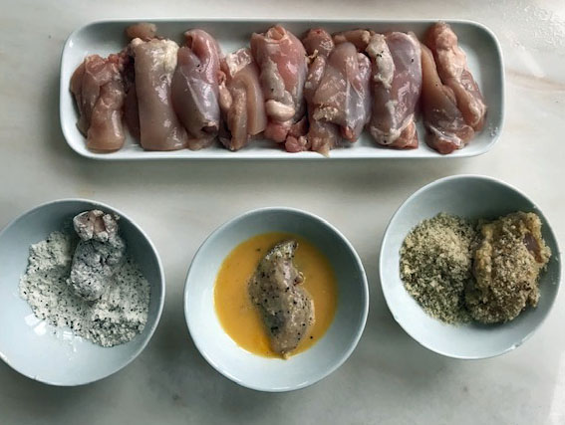

You will need:
500gms chicken thigh filets cut into two pieces.
2 heaped tablespoons of plain flour
1 teaspoon each of salt and pepper
1 large or 2 small eggs beaten together
Breadcrumbs made from two slices of bread (a couple of days old is best)

- Cut the chicken thigh filets into at least two pieces.
- Prepare three bowls: one with flour and salt and pepper, one with beaten egg and one with breadcrumbs. (breadcrumbs can be made in a food processer or by grating the bread)
- Roll each chicken piece in the flour, then roll it in the beaten egg and finally roll it in breadcrumbs.
- Heat 2 tablespoons of oil in a frying pan and fry the nuggets for 3-4 minutes on each side.
- Place the nuggets on some kitchen roll to get rid of excess oil.

