Chickpea Dip

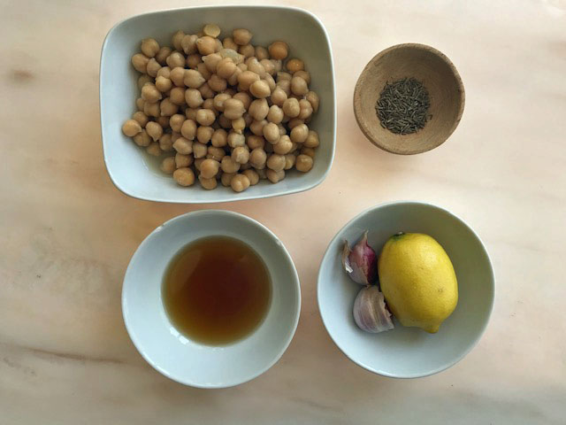

You will need:
I tin of chickpeas
Juice of 1 lemon
2 cloves of garlic - crushed
1 teaspoon of cumin powder or seeds that are crushed
2 tablespoons of oil (Olive oil or Sesame oil or sunflower oil)

- Tip the chickpeas into a saucepan with about a tablespoon of the water from the tin and heat them up.
- Use a hand-held liquidiser and blitz the chickpeas to a smooth puree.
- Add the lemon juice, crushed garlic, cumin powder, oil and some salt and pepper.
- Blitz the whole mixture together.
- Cool the dip in the fridge before you eat it.
(I added a bit of paprika and oil on top for the photo below!)

