Bacon and Mixed Bean Stew

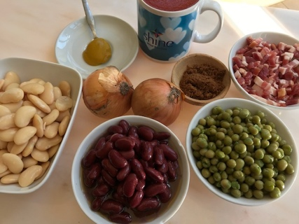

You will need:
Half a mugful of chopped bacon bits
2 onions- chopped
1 tablespoon of oil
1 mugful of Tomato Base (or passata)
1 tablespoon of sugar
1 heaped teaspoon of mustard
1 mugful each of three types of beans or peas – you could use red kidney beans, chickpeas, tinned peas, butterbeans or cannelloni beans. You can add a bit of parsley or coriander if you have some.

- Fry the onions in a saucepan for 5-8 minutes until they are soft and transparent and remove them from the pan while you fry the bacon pieces until they are cooked through.
- Put the onions back in the pan with the bacon bits and now add the tomato base, sugar and mustard and bring to the boil.
- Stir in what ever combination of beans/peas you are using and cook gently for 5 -10 minutes stirring all the time until everything is combined and heated through.
(I made sweet potato wedges to go with these beans – peel the sweet potatoes and cut into wedges. Toss them in oil and put into the oven on a baking tray at 200C for 20-30 minutes until they are crisp at the edges)

