Cheesy Leek and Potato Bake

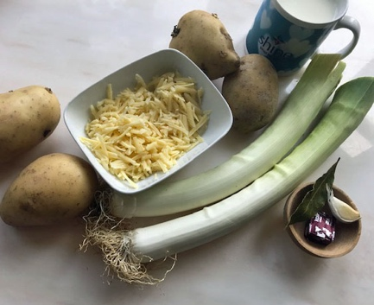

You will Need:
4 large potatoes
2 large leeks
½ of mug full of grated cheese.
1 mug full of milk
½ a mug full of stock
1 clove of garlic
1 bay leaf (optional)

- Peel and thinly slice the potatoes
- Slice the leeks very thinly (after removing the roots and the tops)
- Crush the garlic clove into the milk and heat it up in a saucepan with the bay leaf (if using)
- Butter a large baking dish
- Now mix the leeks and potatoes in the dish with a layer of the sliced potatoes on the top. Add salt and pepper.
- Pour both the warm milk and the stock cube dissolved in ½ mug full of boiling water over the mixture
- Sprinkle the grated cheese over the top
- Cover with some tin foil and bake in the oven for 30 minutes at 180C
- Take the foil off and bake for another 30 minutes until the potatoes are cooked through and the top is golden

