One large Chicken – three meals for 4 people

Meal 1. The Roast Chicken
Put one large chicken in a metal roasting pan in the oven at about 180C for 2 hours. Half way through cooking you could spoon the fat over the chicken but otherwise there is nothing you need to do.
In the hour before the chicken is ready you could put some potatoes in the oven to roast and cook some vegetables for a wonderful healthy dinner that smells great.

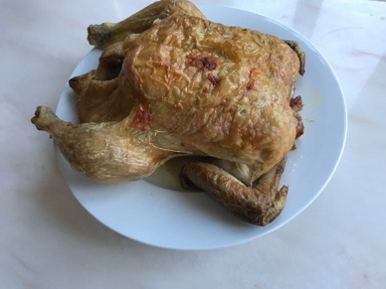

Meal 2. Spiced Chicken with baked sweet potato

You will need: All the chicken that is left on the bones after your roast meal
6 Tablespoons of mayonnaise
2 teaspoons of curry powder
2 Tablespoon of any chutney
4 sweet potatoes or 4 Baking potatoes
Wash and the potatoes and cook in the oven at about 180C for an hour. Sweet potatoes cooked quicker that ordinary potatoes. Just squeeze them to check that they are soft and cooked all the way through.
- Cut the chicken into chunks
- Put the mayonnaise into a dish and sprinkle in the curry powder
- Stir in the chutney and mix everything together
- Stir in the chicken chunks
- When the potatoes are cooked cut them in half and pile the chicken on top. You could also add some salad

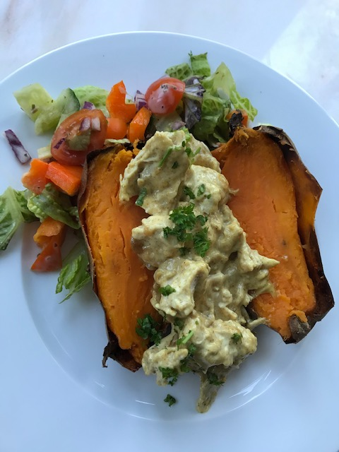

Meal 3. Chicken soup.

You will need: The chicken carcass
1 onion chopped in small pieces
3 carrots chopped into small pieces
A handful of frozen peas
(Any leftover vegetables or gravy from your roast dinner)
1 layer of noodles broken into small pieces
Salt and pepper and herbs

- Put the chicken carcass in a big pan and cover it with water
- Slowly boil the bones for about 20-30 minutes
- In another pan fry the onions and carrots gently for 5 minutes
- Once the chicken stock is ready pour it through a sieve into the onion/ carrot pan
- Add in any leftover vegetables or gravy and some frozen peas
- Brake up some noodles and add them to the pan.
- If there are any little bits of chicken left on the bones they can be added too
- Add some salt and pepper (and parsley or rosemary if you have any)

