Rainsticks

Something to think about:
There is no rainbow without rain

Materials:
Pringles tube or something similar
Lentils /pasta / rice
Tape
Coloured
Glue
(optional) nails and hammer

Method:

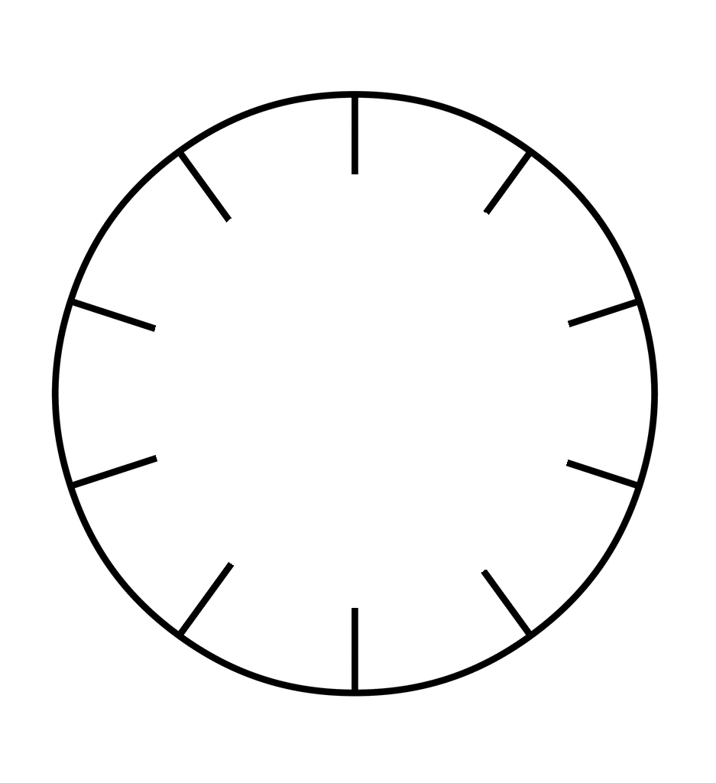
- If you don’t have a pringles tube, you might have to block off the ends of your tube. To do this, cut a circle of paper out a bit bigger than the end. Cut into the edge of the circle like so:

Place over end of tube and squish down outside of circle, tape in place
- If you have hammer and nails (these can be quite small like tacks), hammer nails into the sides of the tube at random places
- Cover over the heads of the nails with tape
- Fill tube with pasta/rice/lentils
- Put lid on and tape in place
- Now decorate outside by sticking torn up/cut coloured paper all over. You can add glitter or anything else you like.
- Put on your favourite piece of relaxing music and move the rainstick so that the contents slide up and down. Ahhh!

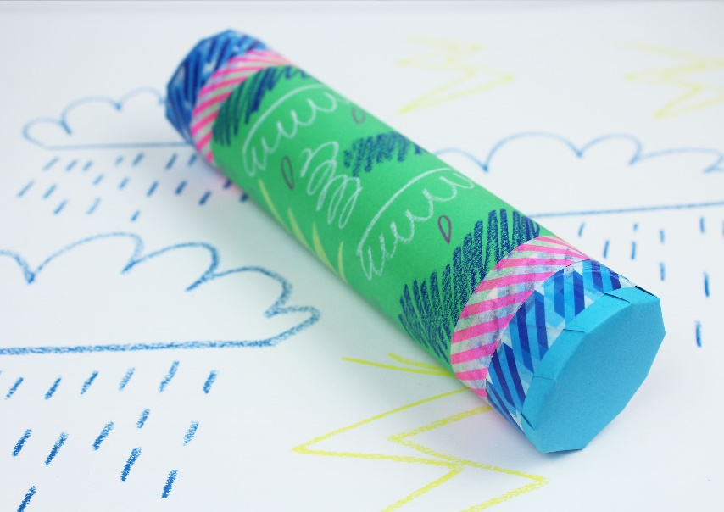

https://www.youtube.com/watch?v=NQgwPSmWLzw

