Chocolate and Banana Loaf

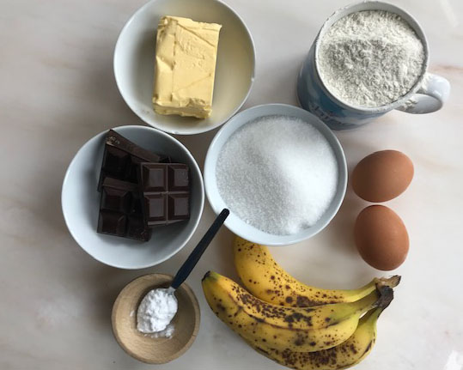
You will need:
Half a 250g block of butter/margarine (125g)
Half a mug of sugar (175g)
A full mug of self -raising flour
2 eggs (or half a mug of egg mix)
1 teaspoon of bicarbonate of soda
2 large or 3 small ripe bananas
Some chocolate – either Chocolate drops or some chopped up block (about 100g)
2lb/large Loaf Tin – lined with some baking paper (or the paper from the margarine block)

- Melt the butter or margarine and the sugar in a saucepan.
- Add in the flour and bicarbonate of soda and mix really well
- Mash up the bananas and stir them into the mixture
- Lightly beat the eggs with a fork and then add them to the mixture
- Beat the mixture well together – it will be quite sloppy now
- Leave it to cool while you get a baking tin ready and chop up the chocolate
- Stir in the chopped chocolate and tip the mixture into the lined loaf tin.
- Cook at 160C for 30-40 minutes.
- Leave it to cool in the pan before taking it out. (I sifted some icing sugar over the top)

This didn't last long….

