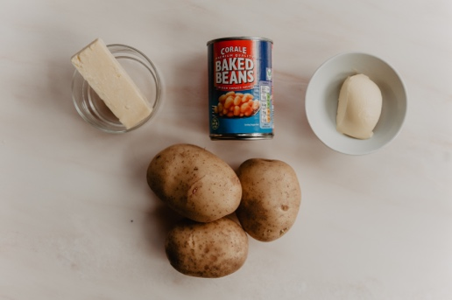

You need;
A potato for each person.
About 150gms of cheese
I tin of beans
Butter or margarine.

Wash the potatoes and then prick them with a knife
They will cook in a hot oven (about 180C or gas 6 ) in about an hour.
If you want to speed things up you could put them in a microwave for 10minutes first then put them in the oven. They are cooked when they feel soft when you squeeze them gently and they feel soft inside.
Take them out and cut in both directions and pull apart. Add some butter and some grated cheese and pop back in the oven for 5 minutes for the cheese to melt. You can heat up the beans now….. and here is a very easy but nutritious meal.

