Potato and Parsnip Bake (4 people)

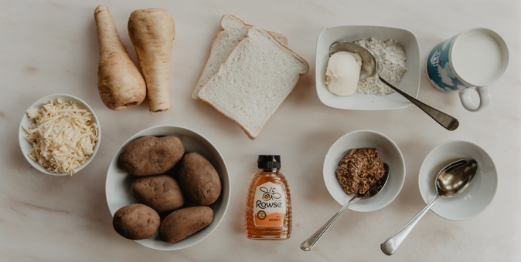

I used a sauce made with mustard vinegar and honey to give these vegetables a kick of flavour. You could also use a cheese sauce – just add another half mug of grated cheese to the white sauce. You can also use any type of flour to make the basic white sauce!
You will need:
500g potatoes – about 4 large ones peeled and cut into chunks
500g parsnips – 2 large or 3 medium sized ones peeled and cut into similar sized chinks
For the basic white sauce: 1 tablespoon of margarine, 2 tablespoons of flour, 2 mugs of milk.
For the flavour: 2 tablespoons of wholegrain mustard, 1 tablespoon of clear honey and 1 tablespoon of vinegar. OR: 1 half mug of grated cheese
For the crunchy topping: 2 slices of bread and half a mug of grated cheese
- Boil the potato and parsnip chunks in water for about 5 minutes then drain them and put them in an oven- proof dish
- Make the sauce by slowly melting the margarine in a pan and stirring in the flour. Cook for a minute then add the 2 mugs of milk a little at a time , over the heat and stirring all the time until you get a smooth sauce. It will be quite thin but this is OK.
- Now add your flavour – either the honey and mustard and vinegar option or the cheese option.
- Pour this thin sauce over the potatoes and parsnips
- Grate the bread so that it is in rough crumbs and mix it together with more grated cheese and sprinkle it over the top of the potatoes, parsnips and sauce.
- Bake in the oven at 170C for 30 minutes. The top should be crunchy and the sauce will soak into the potatoes and parsnips.

