FRIENDSHIP BRACELETS
Something to think about: A friend in need is a friend indeed
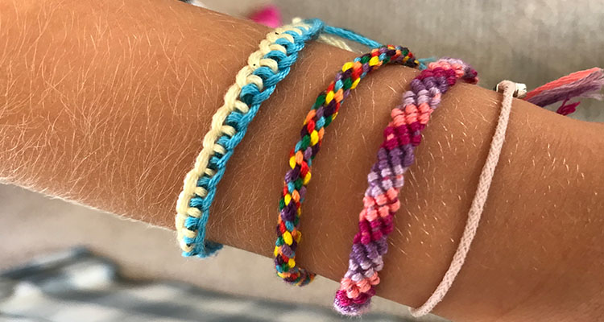

Materials:
Wool, tape

Method:
- There are two simple ways to make a friendship bracelet.
- First method: take three lengths of wool, three times the width of your wrist. Tie them together at one end and tape this down onto a table. Take the left piece of wool and knot it once around the central length, repeat this with the right hand piece of wool. Keep doing this till you have made a whole bracelet. Tie off at the end and tie together around the wrist.
- Second method: take eight piece of wool and tie them together, tape these down as before. Lay out the eight in two sections of four so you can see each strand. Now take the outside length on the right into the centre. Take the outside length on the left into the centre. Keep doing this until you have made a bracelet. Tie off at the end.
- Make these for yourself and wear to remind you of your friends, or you could send it through the post to a friend.

https://www.youtube.com/watch?v=u5knLsLjlaE
(First two methods are easiest but people might want to try the others)

