Easy/flexible cake recipe.

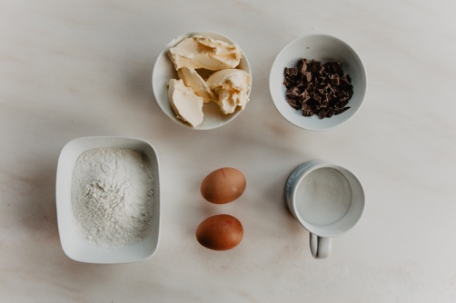

You will need:
Two large eggs
150g /Three heaped tablespoons of butter or margarine
150g / ¾ mug of self-rising flour
150g/ ½ mug of sugar.

1.If you have a hand mixer then put all the ingredients into a bowl and whisk them together until they are well mixed and paler in colour.
2. If you are making them by hand then start by beating the margarine and sugar together until they are pale looking. Beat in the eggs one by one. This will be hard work! When this is well mixed then gradually add in the flour (and cocoa powder/coffee and walnut/lemon zest if you are using any of them).
If you are using chocolate chips or walnuts then stir them in right at the end.
3. Now put this mixture into either small cake cases, muffin cases or a 20cm round deep cake tin that has been greased and lined with baking paper.
4. The cooking time will depend on the size of the tin or case. The smaller the case the quicker the cooking time. For small Cake cases try 10-15 minutes, For Muffin cases try 20 minutes, For the whole tin test after 25-30 minutes. Cook at 160 C Gas 4
The cakes are cooked when they are springy to your touch and slightly drawing away from the tin or case.

Chocolate chip: If you want a chocolate cake then take out a tablespoon full of the flour and exchange it for a tablespoon of cocoa powder. Add in some chopped chocolate pieces at the end
Lemon: Use grated lemon zest and ½ the juice of a lemon
Coffee and walnut: Add in two teaspoons of instant coffee powder dissolved in a tablespoon of hot water and a handful of chopped walnut pieces.

