Couscous with Chickpeas and Dates

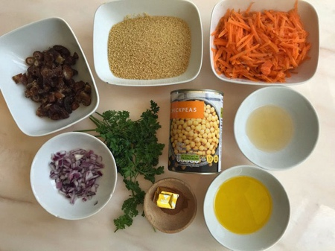

You will need:
I tin of chickpeas
Half and mug of dates- chopped into small pieces
3 grated carrots
1 mug of couscous (150gms)
2 mugs of water
1 tablespoon of chopped onion (either red, white or spring onions)
1 stock cube
2 tablespoons of vinegar and 4 tablespoons of oil
1 heaped teaspoon of cinnamon, about ½ teaspoon each of salt and pepper.
A handful of parsley
- Take a large bowl and pour in the mugful of couscous.
- Melt the stock cube in one mug of boiling water then add it and another mug of water to the couscous and leave it to stand for 5 minutes while the couscous soaks up the water.
- Leave the couscous to cool then add the Chickpeas, Dates, carrots, and onions and mix together really well.
- To make the dressing put the vinegar, oil, salt, pepper and cinnamon in a small bowl and beat them together.
- Pour the dressing over the couscous. Sprinkle the parsley over the top of the salad.

