Spaghetti Carbonaro for 4 people

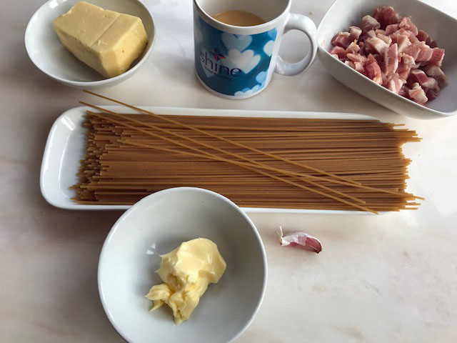

You will need:
4-500gms of spaghetti – any type will do
3 tablespoons of bacon pieces.
1 clove of garlic – finely sliced
1 desert spoon of butter/margarine
Half a mug of grated cheese
Half a mug of 80%egg 20% milk mix or 2 eggs and 2 tablespoons of milk lightly beaten together.

- Cook the spaghetti according to the instructions on the packet.
- While the spaghetti is cooking fry he bacon pieces in the butter until they are crisp.
- Add the garlic for the last couple of minutes.
- When the spaghetti is cooked drain off the water leaving the spaghetti in the pan.
- Add the bacon pieces to the spaghetti then stir in half the grated cheese and stir in the egg mixture. The heat of the spaghetti cooks the eggs quite quickly so serve it at once with the rest of the cheese sprinkled in top.

