Fruit Crumble

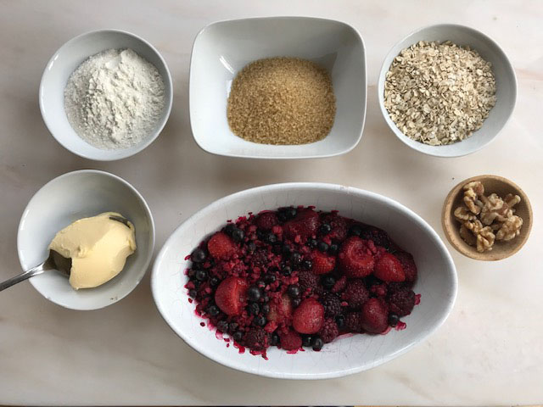

You will need:

Half a bag of mixed frozen berries.
Half a mug of oats
Half a mug of flour (any type)
Half a mug of sugar (I like demerara because it stays crunchy but white granulated is fine)
One heaped tablespoon of margarine
Some chopped nuts if you have any (for extra crunch)

Put half a bag of frozen berries in a dish and put the dish in the oven while its warming up to 150C /Gas 4
Take the oats, flour and sugar and tip them into a bowl.
Put the margarine in with the dry ingredients and then work it through them with your fingertips until all the mixture has some margarine in it and none of it is still dry.
Chop up some nuts into small pieces if you are using them.
Now take you fruit out of the over – it should have defrosted – and sprinkle over about a tablespoon more sugar to take away the sharpness of the fruit.
Now sprinkle the crumble mixture over the fruit with the chopped nuts on top and put the dish back in the over for 20-25 minutes.
You could eat this with ice cream or yoghurt

