Pepper and Bean Chilli with Rice for 4

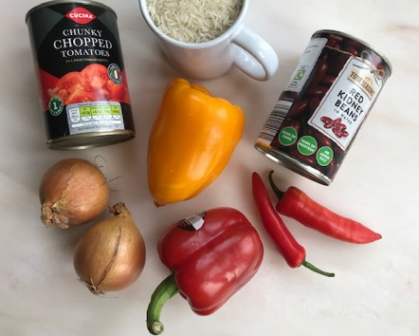

You will need:
Two Peppers
Two Onions
Two Chillies
1 tin of chopped tomatoes
1 tin of Red Kidney beans
240gms /one full mug of rice

- Thinly slice the onions to form rings
- Slice the peppers and the chillies into rings too
- Melt some butter or oil in a large frying pan and gently cook the onions for about 5 minutes
- Add the peppers and chillies and continue to gently fry for 5 more minutes
- Wash the rice and simmer it in 2 mugs of water and ½ a teaspoon of salt for about 15 minutes. Leave it with the lid on the pan until you want to serve the meal
- Add the tin of tomatoes and the tin of beans to the peppers in the frying pan.
- Half fill the tin of tomatoes with water and add that to the pan. Season with some salt and pepper.
- Slowly cook together for about another 10 minutes
- Serve the cooked rice – sprinkle with parsley or coriander if you have any.

