Vegetable and bean risotto.

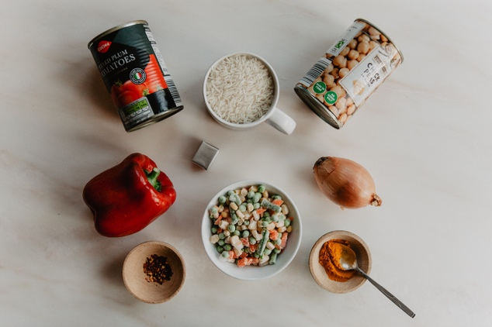
You will need:
1 chopped onion
1 full mug of rice
1 tin of tomatoes
1 tin of beans
1 Red Pepper
Extra vegetables
I teaspoon of Turmeric
¼ teaspoon of Chilli flakes
Stock cube
Tablespoon of oil, salt, pepper

- Chop up the onion and start to fry it in a big pan with a tablespoon of oil.
- Add in the turmeric and the rice and fry them all together stirring to coat the rice in the spice.
- Next add the tinned tomatoes and the chopped red pepper with the chilli flakes and ½ a teaspoon of salt
- Fill the tomato tin with water and add to the pan with a stock cube.
- Stir to mix everything and then put the lid on your pan and let it simmer gently for 15 minutes stirring occasionally to stop it sticking to the pan.
- You might need to add more water as the rice absorbs it as it cooks
- Next add the beans and any extra vegetables that you have and cook for another 5 minutes.
- You could sprinkle chopped Coriander leaves over the top if you have any.

This recipe is very flexible – you could use any beans – butter beans or chick peas or kidney beans.
The extra vegetables could be a tin of sweetcorn, some frozen peas or some frozen mixed vegetables. Just adjust the cooking time – add them early if they take longer to cook.

