Carrot and Sweetcorn Fritters

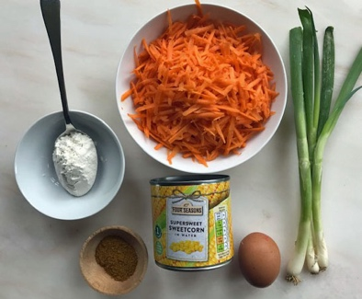

You will need:
2 mugs of grated carrot
1 tin of sweetcorn
3 spring onions- finely chopped.
2 tablespoons of flour
1 egg
1 teaspoon of curry powder (optional)
Salt and pepper
Tablespoon of oil for cooking

- Put the grated carrot and sweetcorn and finely chopped spring onions into a large bowl.
- Stir the flour, salt and pepper and curry powder (if using) into the vegetables.
- Crack the egg into the bowl and mix it thoroughly into the vegetables.
- Leave to stand for a few minutes.
- Heat half the oil in a frying pan over a medium heat.
- Make a few round fritters in the frying pan with a tablespoon.
- Fry for about 2 minutes on one side then flip the fritter over and fry on the other side for two minutes. The fritter should look golden brown.
- Add more oil to the pan and keep cooking fritters until all the mixture is finished.
(Great with sausages or burgers or fish fingers)

