Butternut squash and chickpea curry

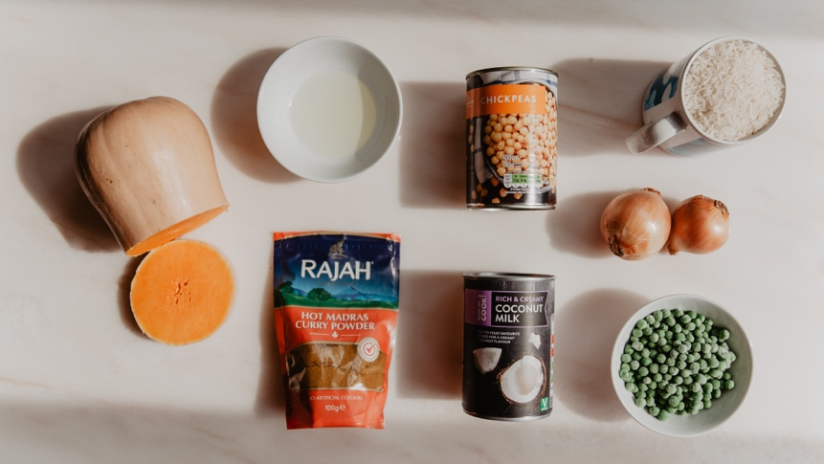

You will need:
Half a large butternut squash (chopped into 1cm cubes)
1 tablespoon of oil
I can chick peas
I can coconut milk
2 teaspoons of hot curry powder
1 stock cube
1 Large or two small onions
1 full mug of rice /250gms
Salt and pepper
Some green vegetables (I used some frozen peas but green beans would be good)

Chop up the onions and fry them slowly in the oil for about 5 minutes
Stir in the 2 teaspoons of curry powder and cook for a minute
Stir in the coconut milk and then fill the can up with water and add that too with the chicken stock cube
Stir in the butternut squash cubes and simmer for 10 minutes
Meanwhile start cooking the rice.
Next add the chick peas and continue to simmer for another 10 minutes
Now add the peas or beans for the last 5 minutes. (the aim is that the butternut squash is cooked until its soft)
If you have any coriander you could sprinkle some over the top

