Spicy Noodle Salad

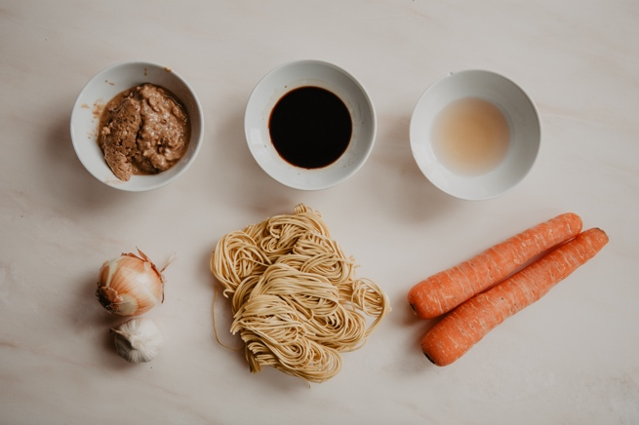

You will need:
4 Tablespoons of peanut butter (crunchy is good)
3 Tablespoons of soy sauce
2 tablespoons of vinegar
4 nests of noodles
2 large carrots- grated
Half an onion -grated
1 clove of garlic- finely chopped
1 tablespoon of chilli sauce (if you have some)

- Put the peanut butter, soy sauce and vinegar in a bowl and mix them together into a paste.
- Grate the carrot and onion into a bowl.
- Cook the noodles until they are as soft as you like them.
- Drain the noodles and then put them back in the pan.
- Mix in the peanut sauce and the vegetables through the noodles. Add the chilli sauce (if using)
- Eat immediately.

