Yorkshire pudding sausages. (4 people)

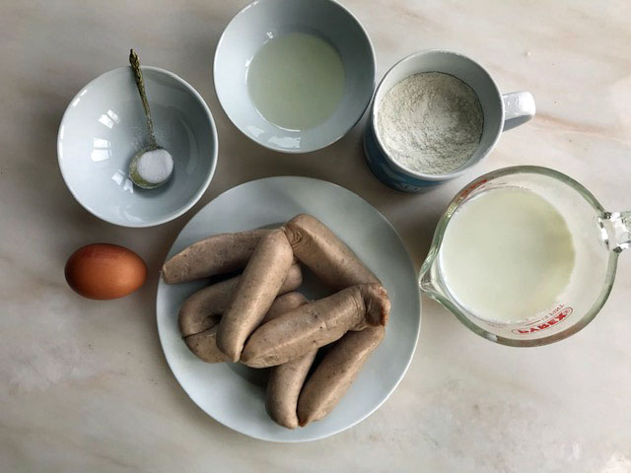

You will need:
A packet of 8 sausages
¾ Mug of flour / 130g
1 large Egg
½ teaspoon of salt
2-3 tablespoons of cooking oil
1 mug full / 280mls of milk

- Put the sausages in a roasting tin in the oven at 220C and cook them for 20 minutes while you make the batter. They should be browned and cooked through.
- Put the flour and salt into a mixing bowl and make a small crater in the flour. Crack your egg into the middle of the flour in the crater. Start to mix the egg into the flour with a fork.
- Add some of the milk as you go so that you gradually have no dry flour left. Now begin to add more milk a little at a time and try to get your batter smooth with no lumps of dry flour. You could beat it with a whisk to get rid of lumps. The batter should be like thick cream
- When the sausages are cooked take the tin from the over and pour in the oil. Put the tin in the oven again for 2 minutes for the oil to heat up. Next pour the batter over all of the sausages and put the tin back in the oven for about 20 minutes.
- The batter should be risen and crisp. Eat it as soon as you can -its best straight from the oven with some gravy and some vegetables or baked beans.

