Date and peanut butter sweets that children can make

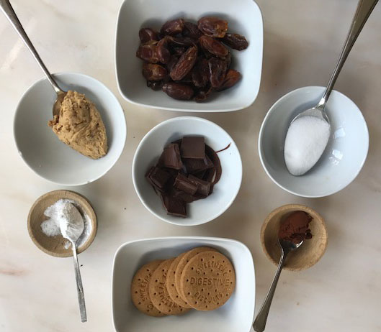

Basic ingredients
Half a mug of dates
1 tablespoon of peanut butter
1 tablespoon of sugar
3-4 plain biscuits
Optional coatings
1 teaspoon of icing sugar
1 teaspoon of cocoa powder
About 10 squares of a chocolate bar

- Put the dates on a chopping board and cut them into very small pieces
- Put the biscuits in a polythene bag and crush them with a rolling pin so that they are powdery crumbs.
- In a bowl begin to combine the dates, sugar, peanut butter and biscuit crumbs. The mixture should end up holding together enough to form into balls. You might need to add more biscuit crumbs if it’s too sticky or more peanut butter if it’s too dry until the consistency works.
- Make about 10-12 small balls by rolling them between your hands then either roll them in a bit of icing sugar, or cocoa powder.
- To coat them in chocolate you would need to put the squares of chocolate in a small bowl and heat them in a microwave until they are melted (about 2-3 minutes) Then dip each ball in the melted chocolate and put it somewhere cool to set.

