Peanut Butter Biscuits

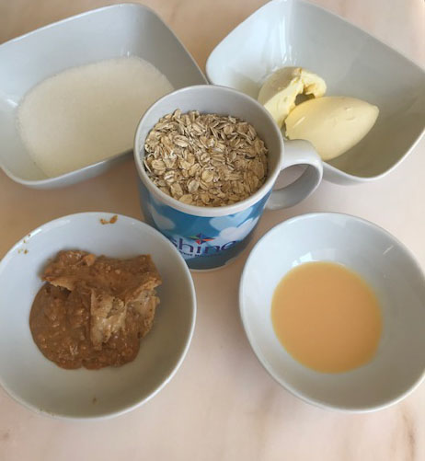

You will need:
2 tablespoons of peanut butter
2 tablespoons of margarine or butter
4 tablespoons of sugar
10 tablespoons/one mugful of oats
1 egg or 1 tablespoon of egg mix
A pinch of salt
- Warm the oven to 160C and get a baking tray ready. Put some baking paper on the tray or just grease it well with margarine to stop the biscuits sticking.
- Melt the peanut butter and margarine or butter in a saucepan
- Stir in the sugar and warm it until its melted
- Stir in the oats and the egg or egg mix.
- Beat the whole mixture together
- Use about a dessertspoonful of mixture for each biscuit and space them out on the tray because they will spread a little whilst cooking
- Cook for 10-12 minutes until they are browned and golden.
- Leave them to cool for 5 minutes on the tray then cool them on a wire rack- they crisp up as they cool.

