Paper chains

- Cut long thing strips of paper
- Take one strip, and curl it round till it touches itself and glue using a glue srick
- Take your second strip, post it through the first one and glue to make the second link
- Carry on till you have enough

Daisy chains

Perfect for the spring!

- Take a piece of paper and cut it into a long strip
- Fold it in half, in half again, and in half again. Draw the shape below making sure that the centre of the flower is on the centre fold

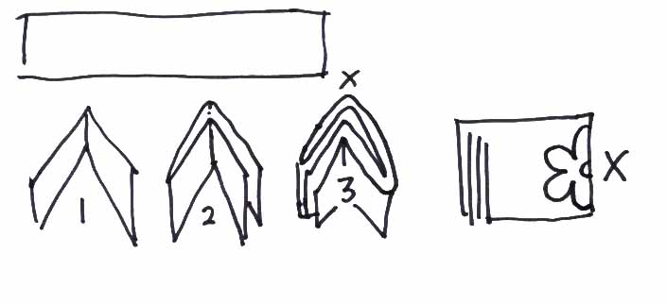
- Cut out the shape and unfold to reveal the daisy chain! You can sticks several together to make a long decoration

http://www.chifudesign.com/paper-cutting-decoration-how-to-paper-cutting-flower-chain-christmas-paper-decorations-step-by-step/
