GOD’S EYES
Something to think about: stay safe!
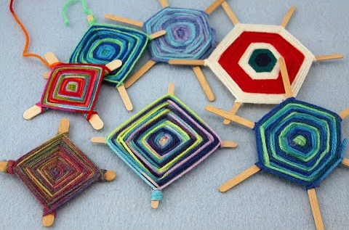

Materials:
Wool, lolly sticks or strips of card or twigs, scissors

Method:
- Use a length of wool to tie your sticks together in a cross shape. You can make an extra cross and add it diagonally so making a star shape if you like
- Cut a length of wool and tie it to the centre of your cross/star. Take your wool around to the first stick ‘arm’ and take the wool from the front of the stick to the back of it, wrapping around the stick, then turning the whole thing quarter turn to the next ‘arm’. Repeat the process, going round and round to make a spider web type design.
- When you have filled the cross to your satisfaction, tie the wool off by knotting it around one of the arms. Make sure you have a long length of wool for this, as the bit left over can be the piece you use to hang the God’s Eye up.
- The God’s Eye was originally a South American craft made as a symbol of protection. We all need to feel safe at the moment, so when you have made this it can remind you of God’s protection and also that you need do what you can to stay safe!

https://www.youtube.com/watch?v=eBasu24q-xE

