Gooey Date flapjacks

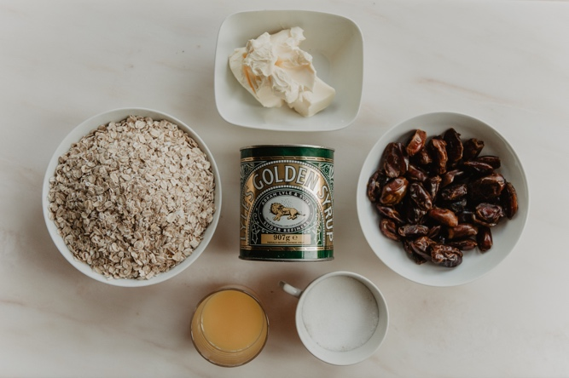

You will need:
2 mugs full of dates
3 mugs of oats
2 tablespoons of sugar
2 tablespoons of golden syrup
3 heaped tablespoons of margarine
3 tablespoons of orange juice. (you could just use water)
- Prepare a square baking tin (20x20cms) by greasing with margarine. If you have a different sized tin just adjust the cooking time – it will cook quicker if it’s across a larger tin
- Put the dates in a pan with the orange juice or water and cook them slowly until they are soft. Add a bit more water if they seem too dry. Then mash them with a fork or potato masher to get a thick paste.
- Melt the Margarine sugar and golden syrup in another pan and then stir in the oats.
- Spread half the oat mixture across the bottom of the baking tin, then spread the layer of dates, then spoon all the rest of the oats on top and smooth the whole thing so that its flat.
- Bake in the oven for about 30 minutes at 160C until it is golden.
- Leave it to cool in the tin before cutting it into squares.

