ORIGAMI HEARTS

Something to think about: “The best and most beautiful things in the world cannot be seen or even touched – they must be felt with the heart” Helen Keller

Materials:
Piece of paper, why not try different types of thin paper like magazines with pictures you like on them, or you could get a plain piece of paper and draw or colour on it first before making the heart.

Method
- You need a square piece of paper. If your paper is a rectangle, you can make it into a square by folding one corner over so that it lines up with the edge of the other side, then cut along the edge across the bottom of the paper – see picture below.

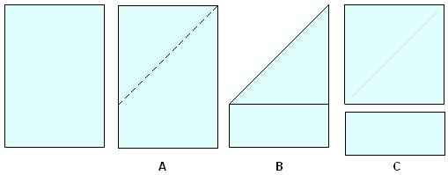

- Now make a heart using the instructions below

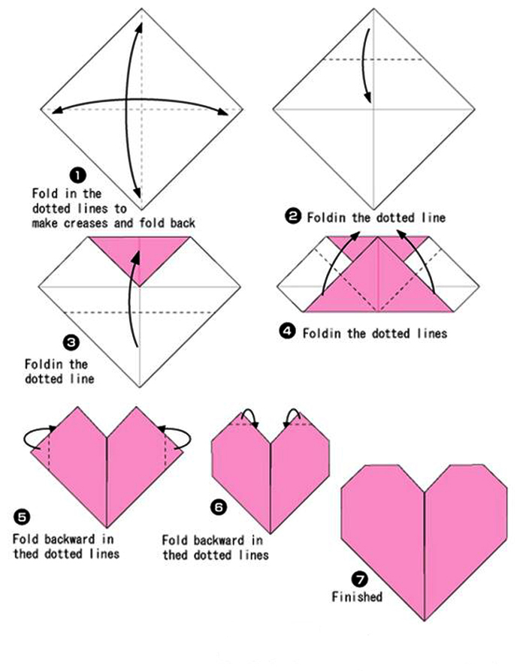

https://www.youtube.com/watch?v=YO7TS6uqya8

