Remembering the Fallen of West Bowling

Biographical Details: | Source/Conf/Saved
Name/Rank: James Henry Busfield – Driver  Serv. No: 141025 - Driver | CWGC  CWGC
Place/DOB Stanningley, Yorks/ 1892 | 1911 Census
Parents: John William Busfield (b. 1854 – Farsley)(Woolcomber)  Ann Busfield (b.1858 - Bramley)(Housekeeper) | 1911 Census
Siblings: Fred (b.1883; Arthur (b.1881); Eliza A (b1887); Willie  (b.1876); Ernest (b.1885); Herbert (b.1890); George W  (b.1894),Tom (b.1900) | 1911 Census
Occupation:  Residence: 1911- 182 St Stephens Road, Bradford  1901- 87 Round Street, Bowling St Stephens  Other- 65 Ackworth Street, West Bowling, Bradford, | 1911 Census  1901 Census  CWGC/G W Busfield
Date, Age & Place of Death: 21st March 1918 / 26 / France  Commemorated: Pozieres Memorial (Panels 7 to 10) | CWGC  CWGC
Other Comments:
Brother of George Watson Busfield – KIA 4th July 1917.

Military
Bn/Regiment: “C” Battery, 232nd Bde Royal Field Artillery | CWGC
Brigade/Division: 46th (North Midland) Division > Army Field Artillery  Brigade, RFA | www.1914-1918.net
Actions Div/Bde involved in/dates:  CCXXXII Brigade, Royal Field Artillery served as Divisional artillery with 46th (North Midland) Division. The North Midland Division was a formation of the Territorial Force and was mobilised for war service on the 5th of August 1914. The Division concentrated in the Luton area by mid August. They proceeded to France, landing at Boulogne in late February being first complete Territorial Division to arrive in a theatre of war when they joined the BEF in the Ypres salient. On the 12th of May the Division was retitled 46th (North Midland) Division. They were in action during The German liquid fire attack at Hooge and The attack at the Hohenzollern Redoubt in October. On the 23rd of December the were ordered to proceed to Egypt via Marseilles leaving the DAC, Divisional Train and the Mobile Veterinary Section behind. All units had arrived by the 13th of January 1916 but they spent just a few days in Egypt, being ordered to return to France where the units left behind rejoined. On the 1st of July 1916 they took part in The diversionary attack at Gommecourt. CCXXXII Brigade left the Division in January 1917 when they became an Army Field Artillery Brigade, RFA.  - See more at: http://www.wartimememoriesproject.com/greatwar/allied/rfaCCXXXIIBrigade.php#sthash.NEzZx6Au.dpuf | Wartime Memories Project

Biographical Account:
James Henry Busfield was born on June 1st 1891 in Stanningley, West Yorkshire. He was one of 10 children that were born to his parents, John William and Ann Busfield. His father worked in the textile trade as a Woolcomber. Like his brother, George, who was also killed in the Great War, James lived most of his life in the West Bowling area and worked as a dyers labourer.

Unfortunately, we do not know when he joined up to serve ‘King and Country’ but when he did he was posted to the Royal Field Artillery where he became a driver. As part of the 46th (North Midland) Division, the 232nd Brigade Royal Field Artillery was involved in many well known operations. These included actions on the Ypres Salient in 1915 and they provided a diversionary attack on Gommecourt on the 1st July 1916, the first day of the Battle of the Somme.

James Henry Busfield was killed on the 21st March 1918 along with three other members of “C” Battery of the 232nd Brigade. They are all remembered on Pozieres Memorial; their bodies have never been found.

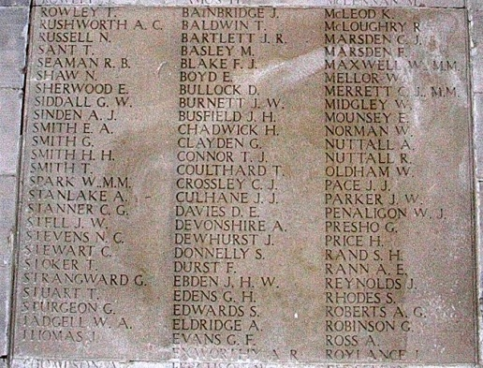
Driver J H Busfield on Pozieres Memorial

